Happy Holidays, 2006!

Dear Family and Friends,

While writing this we are still digesting the wonderful Thanksgiving feast we were invited to share with Roger's brother and his family. They live in Swarthmore, PA, just outside of Philadelphia. Only one of their two boys could be present and daughter Stacey, her husband and two small boys were also absent. They are in Australia for a few years. So it was a small group and a big turkey – which explains why we are still digesting!

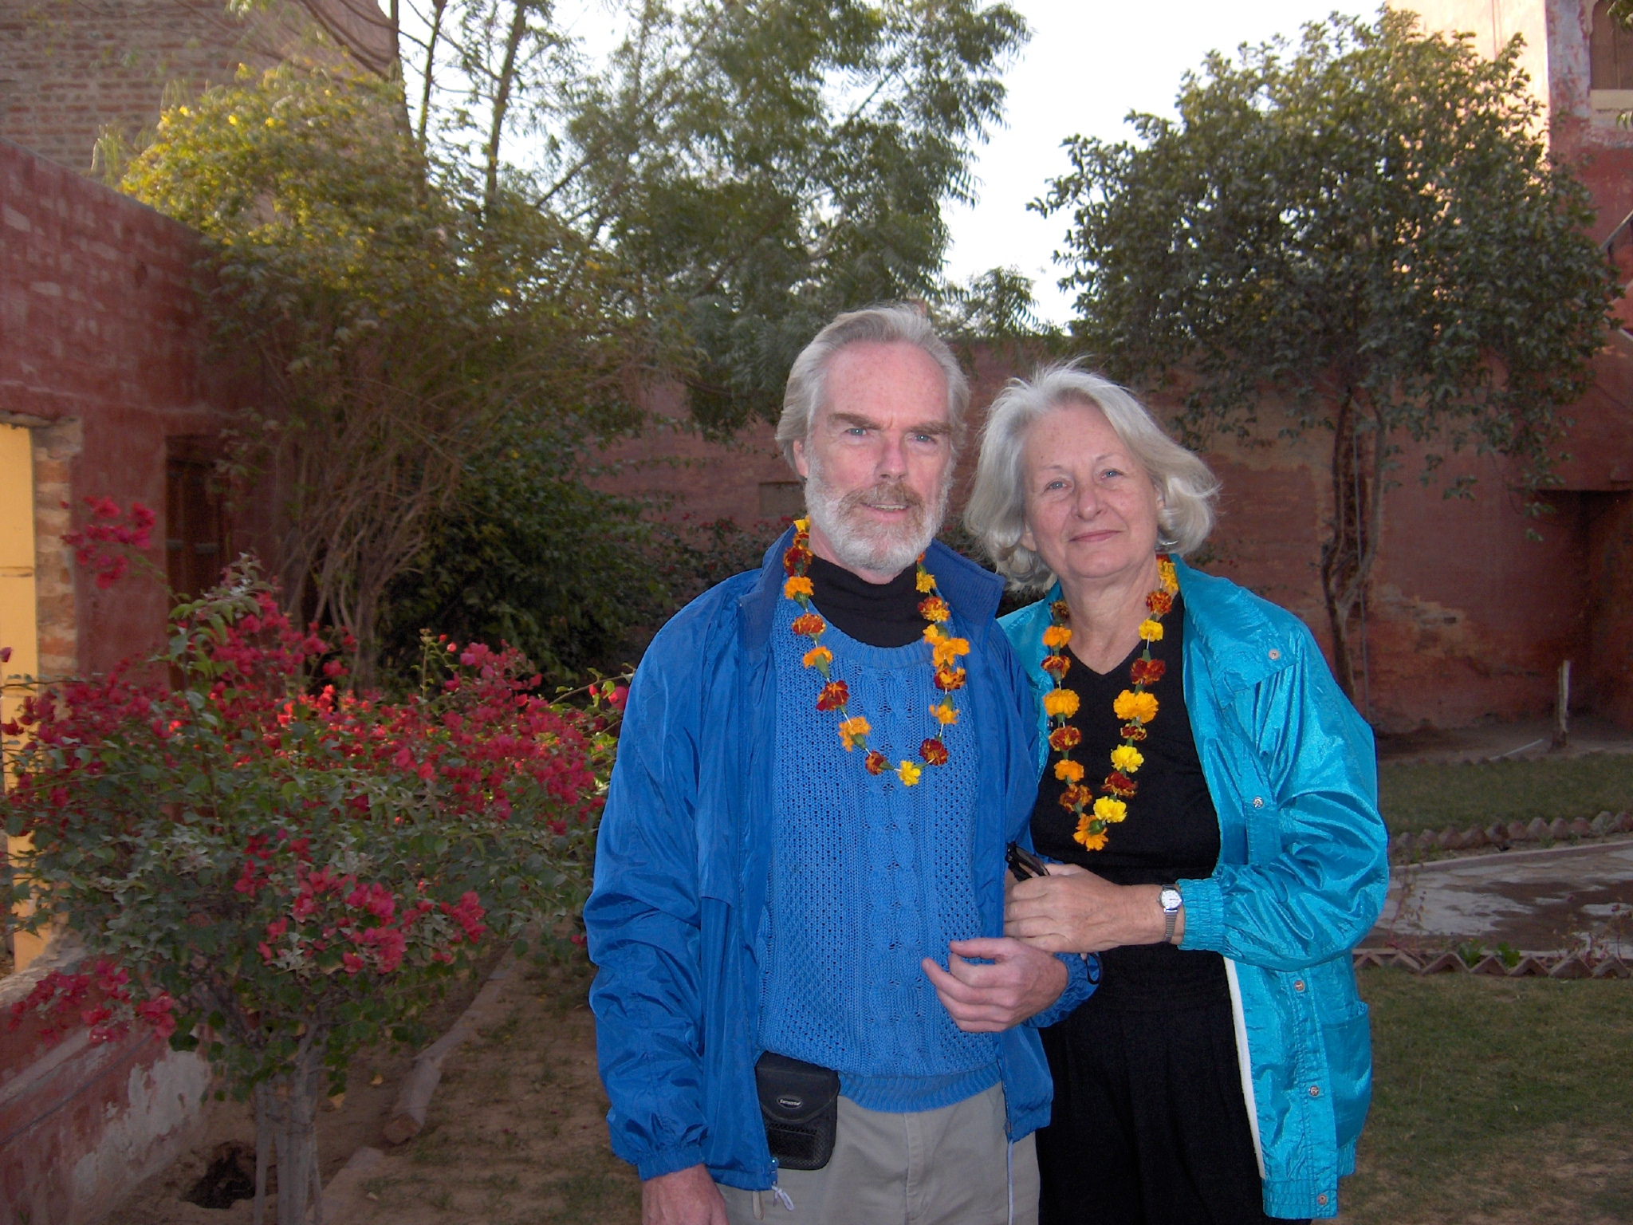
We hope you all had a healthy and exciting year and that we will hear all about it from you. We have been mostly healthy and had much fun traveling. After we got home from India, February 10th, there was a short resting period before the next round of travel. We went to Nebraska, Colorado, and Wyoming on the way to Utah for a conference, and then to England and Sweden. The “retired” Roger also went to San Diego, CA and Petaluma, CA for business. Hmm, the trips to Utah and England and Sweden were business too, so I guess we really did not go on vacation at all.

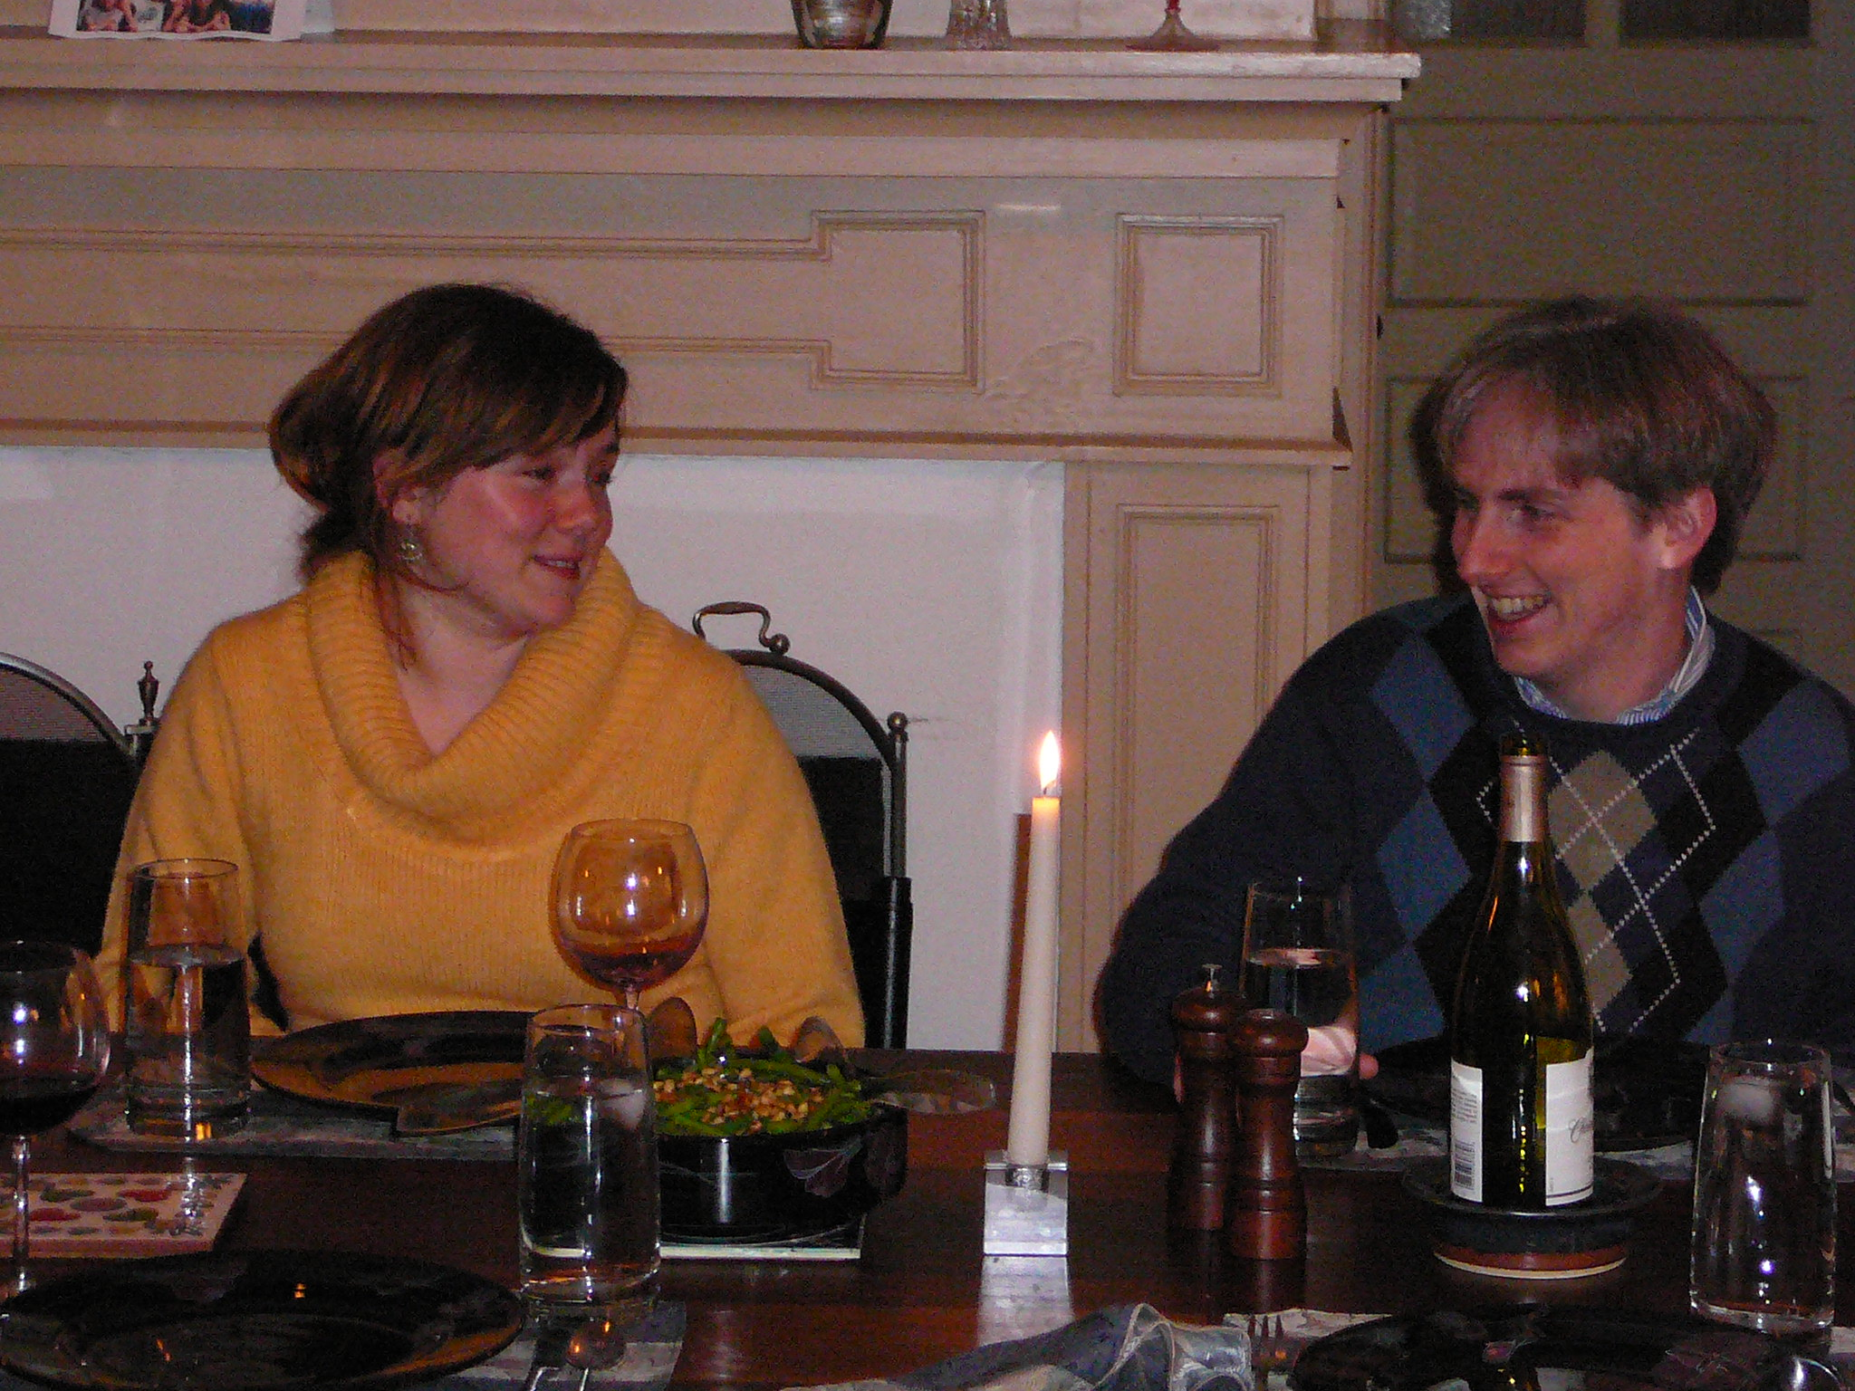
Greg still works for Princeton Gamma Tech (PGT). The company moved to a new location and Greg moved to a new apartment. Instead of 15 minutes he now lives 30 minutes away. There is a new lady in his life, Celanie, and we love her dearly. We feel fortunate to have them nearby.

Life is good!

We are looking forward to spending time with family and friends during this most wonderful season. We wish you a merry Christmas, happy Hanukkah, and a happy and healthy New Year. Last but not least, we wish and pray for Peace on Earth!

Love,
Lefty and Roger

